Inatech 2021 – Day 4 Tasks

1. There are two class level members Name and Age.
   1. Initialize them using object
   2. Initialize them by passing parameters
2. Write a program to implement the membership package for different types of Membership.

Each membership has different benefits in terms of accommodation and Food.

You may choose to implement the abstract class or interface to achieve the same

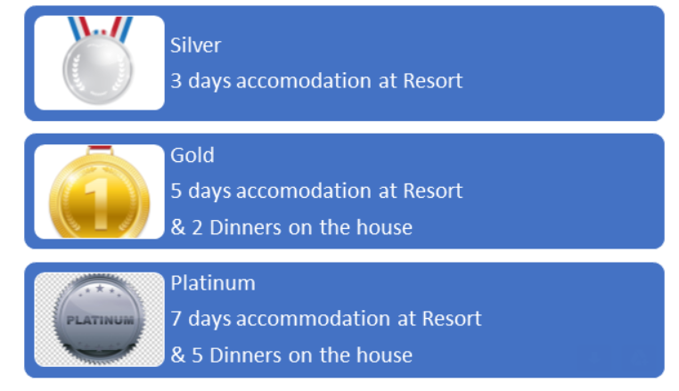

1. **Write a program to get the employee details.**

**Employee has the EmployeeID, Name, Gender, YearsOf Experience, Salary .**

**Employees belong to Sales & Marketing and Production Departments.**

**Sales & Marketing gets 20% bonus of their salary. Write a method to calculate the total salary.**

**Production gets 10% bonus of their salary. Write a method to calculate the total salary.**

**Implement Inheritance and achieve the task.**

**Should print the employee details with salary and bonus.**